NETWORKING 7

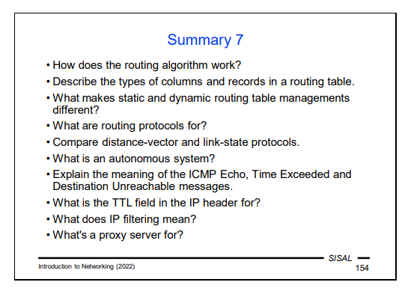

Routing algorithm
The routing algorithm works as followed:
In the record table, the router searches for all matches to the destination of the packet
If no matches are found, the packet is not sent
If multiple matches are found, the one with the wider mask is chosen, the most specific record
If the record references our cmputer(loopback), we place the packet on the input as if it just arrived on the network
If the record is a direct one, we place the packet to the link layer for sending to the recipient
If the record is indirect, we place the packet to the link layer wth information to be sent to the next-hop router
------------
We can describe the routing algorithm as follows:
• In the routing table, the algorithm searches for all records that match the packet’s destination.
• If no such record is found, the packet cannot be delivered. However, this can only be the case if the routing table does not contain a default record (that is, “Other transit” from the analogy with a crossroads). If the table contains one, at least this record will always match. If this situation occurs, the packet is dropped.
• The most specific record (the one with the widest mask) is chosen from the records found. The default record, if any, will therefore only be used if the table does not contain another record that matches the target.
• If the record references our own computer (loopback), the packet is placed on the input as if it had just arrived from the network.
• If the record is a direct one, the packet is directly passed to the link layer to be sent to the recipient.
• If the record is an indirect one, the packet is passed to the link layer with instructions to send it to the next-hop router.

Types of columns and records in a routing table
The records in a routing table can be
- explicit, added by a command either specified by the administrator of the network or run by the OS
- implicit, created automatically by configuring a network interface
- dynamically generated, created during operation of the routing
records can also be formerly cathegorized by their masks, so that a record with mask /32 would be a host record and others would be net or subnet routes.
Columns:
- destination -> network address for which the record is valid
- gateway, either:
  - the next-hop router to which the packet needs to be forwarded if the record is indirect (leads to a foreign network),
  - the address of a custom network interface if the record is direct (leads to a directly connected network).
- netmask -> range of the network

Static and Dynamic Routing Table Managements
Static management of routing tables
Routes installed during startup by configuration
- rigid, not flexible
- problems with subnetting
- complicated solution of backup routes
+ less sensitive, more robust
+ working in totally heterogeneous environment
⇨ suitable for smaller, stable networks

Dynamic management of routing tables
Routers exchange information about the network using some routing protocol; end nodes can listen to it, too, but in read-only mode
+ simpler configuration changes
+ network can react to failures
+ no manual administration of routing tables needed
- more sensitive to errors and attacks
• host must run an application handling the protocol – e.g. routed, gated, BIRD (developed at MFF) – RIP and OSPF are two of the most popular protocols for local networks (internal routers)
-------This is based on the information exchanged between neighboring routers used to adjust their routing tables. The routers communicate with each other using one of the routing protocols. Ordinary stations can also follow this information, but only in passive mode.
-------The simplest approach is the static method of table management, in which a computer has data for all the needed records stored somewhere, and adds them to the table one by one after it boots.

What are routing protocols for?
Routing protocols are used for exchanging data between routers in the same network for data exchange used in the dynamic management of routing tables.
-------This is based on the information exchanged between neighboring routers used to adjust their routing tables. The routers communicate with each other using one of the routing protocols. Ordinary stations can also follow this information, but only in passive mode.

Distance-vector and link state protocol
They are both routing protocols for local networks.
Basic idea of distance-vcetors routing protocol: routing table records contain also “distance” (metrics), each router sends periodically its table to all neighbors, they modify own tables and send them further.
• Advantages: – simple, easy to implement • Disadvantages: – slow reaction to failures – metrics poorly reflects lines properties (bandwidth, reliability, price...) – limited network diameter – one router calculation mistake affects the whole network (routing loops possible)
Baisc idea of link state protocols is that every router knows the entire network map, routers send neighbors state of all their links, every router uses this data for rebuilding the network map.
• Disadvantages: – building map is CPU and memory consuming – during the start and in too unstable networks, the data exchanges can bring heavy network load • Advantages: – flexible reaction to network topology changes – every router builds own map, error does not affect others – network can be divided to smaller areas (build speed!) – data exchange only in case of a failure

What is an autonomous system?
It is a network block with common routing policy. Used to unify routing for a whole group of networks at a global level.

IP filtering
A router that connects a local network to the Internet is the point where the security policy of the entire network is applied. IP filtering is usually a primary part of such a policy. The name is somewhat misleading because it is not really filtering at the IP layer, but on the transport layer. It defines rules on what type of traffic (more specifically, traffic on "which ports") is allowed to and from the local network.

Further on, we will talk about the most important types of messages, so I will only mention the Destination Unreachable message at this point. With this message, a station or router announces that it has no way to deliver a received packet and that it discards it. In the case of a router, this is usually due to a failure to find a matching record in the routing table. In the case of a station, this message most often means that there was an attempt to deliver data to a UDP service that is not available (in the case of TCP, such an attempt is resolved using a response with the RST flag at the transport protocol level, but there is no such option in UDP, so this is handled by ICMP).
Note: The -n option prevents the netstat program from trying to translate IP addresses into names. There are two reasons for this: first, we tend to be more interested in numerical values, and second, with this option we do not run the risk that a broken network will fail to translate an address and we will learn nothing.

Diagnostics:
Netstat –r or route for listing a routing table
Ping for checking whether we can reach the destination and it can reach us as well
The next diagnostic step is likely to be ping, but it usually doesn't help. In fact, if an answer is not returned, there might be various reasons for this and we may not be able to distinguish them. First, our packets may not have reached their destination. Second, they may have arrived, but the target may not be functional. But it is also possible that the packets were lost on the way back. The routing tables work in one direction!
Traceroute -> command, which exploits the properties of the TTL field. The program first sends a packet with TTL 1 to the destination. As a result, if the target lies behind at least one router, the packet won't reach the destination because the router will refuse to forward it and will send back an ICMP Time Exceeded message. The traceroute program will capture it and display the address (and possibly the name) of the router that sent it, including the round-trip
time. The program performs this attempt three times and then starts sending exactly the same packets, but with the TTL increased to 2. These packets now pass through the first router, but are stopped by the following hop. In this way, the program will gradually disclose the structure of the path to the destination. The process will either end in success, or responses will stop coming back at a certain TTL value. The last router that responded to us will then be the starting point of our investigation –either the error is directly at it, or at the next router, or at the previous one (in case the last responding router should never have received our packets).

While ICMP Redirect solves other similar situations, it may also cause problems. If someone (intentionally or by software error) disseminates defective ICMP Redirect packets on the local network, they may cause the network to malfunction. It is therefore usually better to distribute the full network structure to clients and ban the reception of ICMP Redirect.

